Beginner Level Programs
1.Write a program to find the factorial of n number.
Souce code
import java.util.Scanner;
public class FactorialCalculator
{
public static void main(String[] args)
{
Scanner scanner = new Scanner(System.in);
System.out.print("Enter a number to calculate its factorial: ");
int n = scanner.nextInt();
long factorial = 1;
for (int i = 1; i <= n; i++) {
factorial *= i;
}
System.out.println("Factorial of " + n + " is: " + factorial);
scanner.close();
}
}
Output
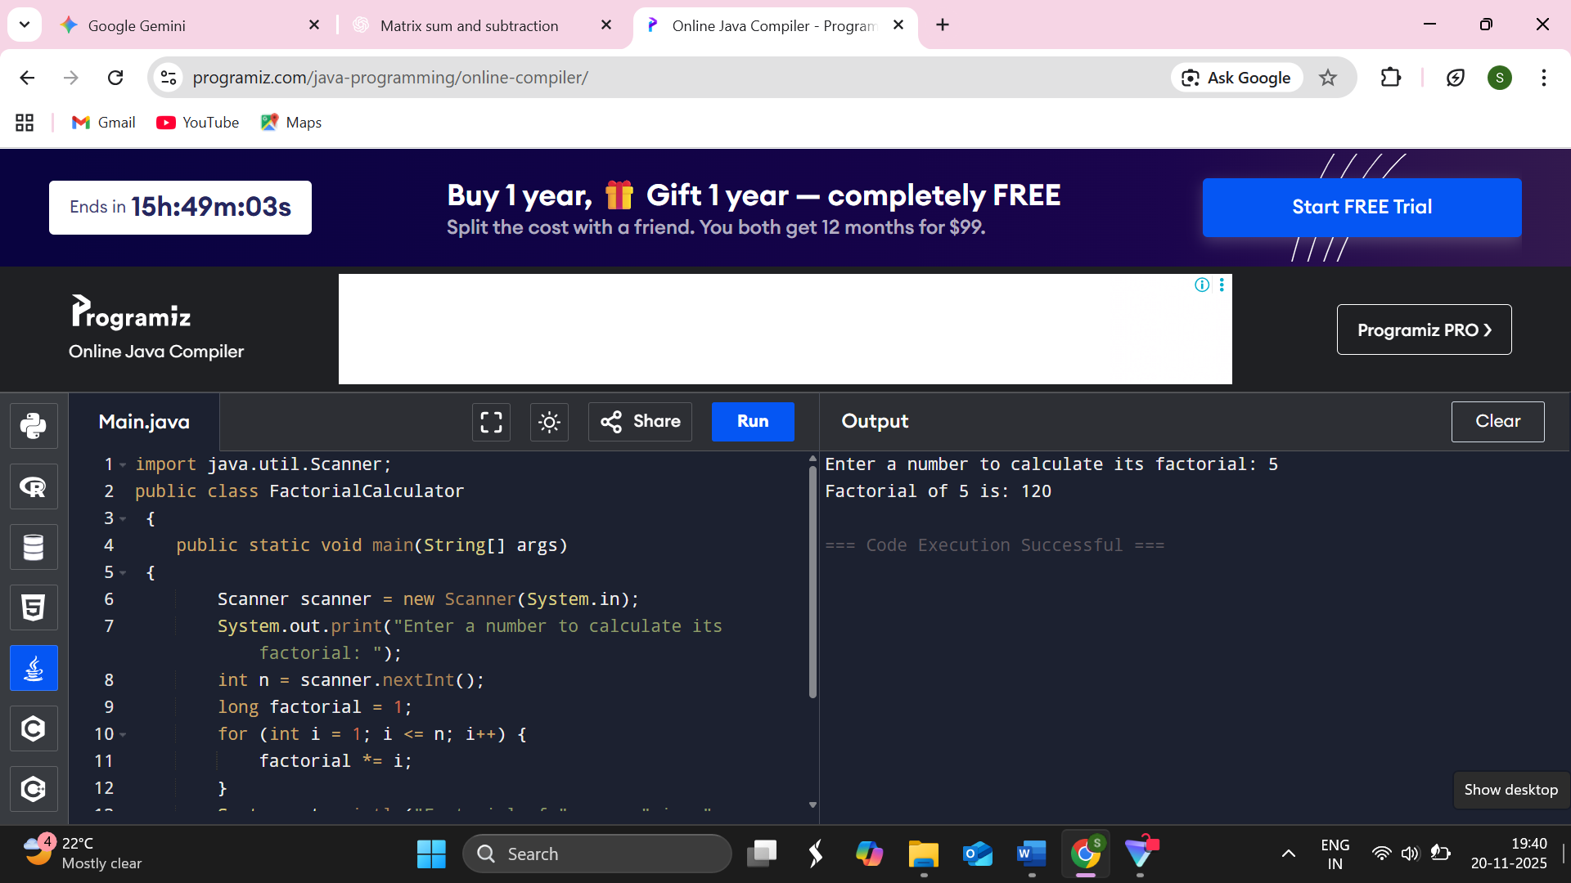

2.Write a program to find the sequence of Fibonacci series up to n terms.
Souce code
import java.util.Scanner;
public class FibonacciSeries
{
public static void main(String[] args)
{
Scanner sc = new Scanner(System.in)
System.out.print("Enter the number of terms (n): ");
int n = sc.nextInt();
int first = 0, second = 1
System.out.println("Fibonacci Series up to " + n + " terms:")
for (int i = 1; i <= n; i++) {
System.out.print(first + " ");
int next = first + second;
first = second;
second = next;
sc.close();
}
}
Output
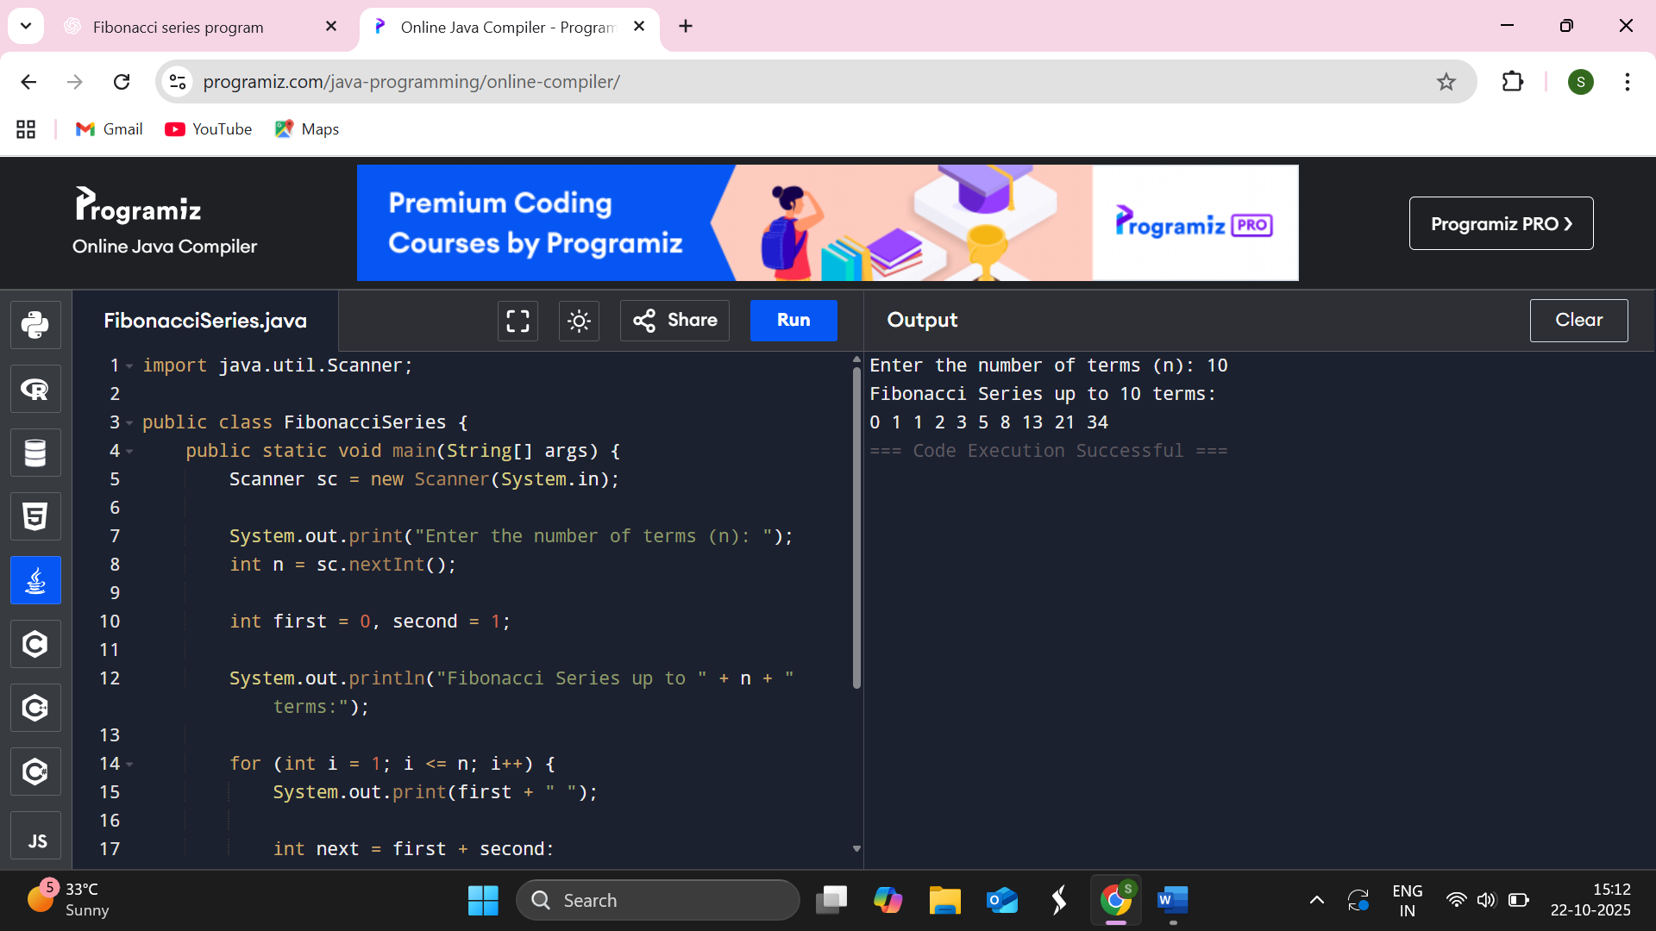

3.Write a program to check whether given number is palindrome or not.
Souce code
import java.util.Scanner;
public class PalindromeNumber
{
public static void main(String[] args)
{
Scanner sc = new Scanner(System.in)
System.out.print("Enter a number: ");
int num = sc.nextInt();
int originalNum = num;
int reversedNum = 0;
while (num != 0) {
int digit = num % 10;
reversedNum = reversedNum * 10 + digit;
num = num / 10;
}
if (originalNum == reversedNum) {
System.out.println(originalNum + " is a palindrome.");
} else {
System.out.println(originalNum + " is not a palindrome.");
}
sc.close();
}
}

Output

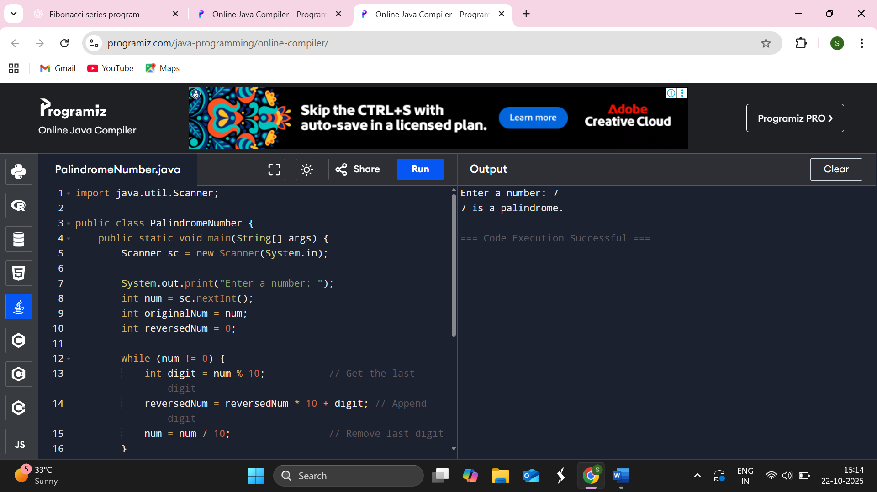

4.Write a program to find the HCF of two number.
Souce code
import java.util.Scanner;
public class HCFofTwoNumbers {
public static void main(String[] args) {
Scanner sc = new Scanner(System.in)
System.out.print("Enter first number: ");
int num1 = sc.nextInt();
System.out.print("Enter second number: ");
int num2 = sc.nextInt();
int hcf = 1;
// Find HCF using loop
int min = Math.min(num1, num2);
for (int i = 1; i <= min; i++) {
if (num1 % i == 0 && num2 % i == 0) {
hcf = i;
}
}

System.out.println("HCF of " + num1 + " and " + num2 + " is: " + hcf);

sc.close();
}
}
Output
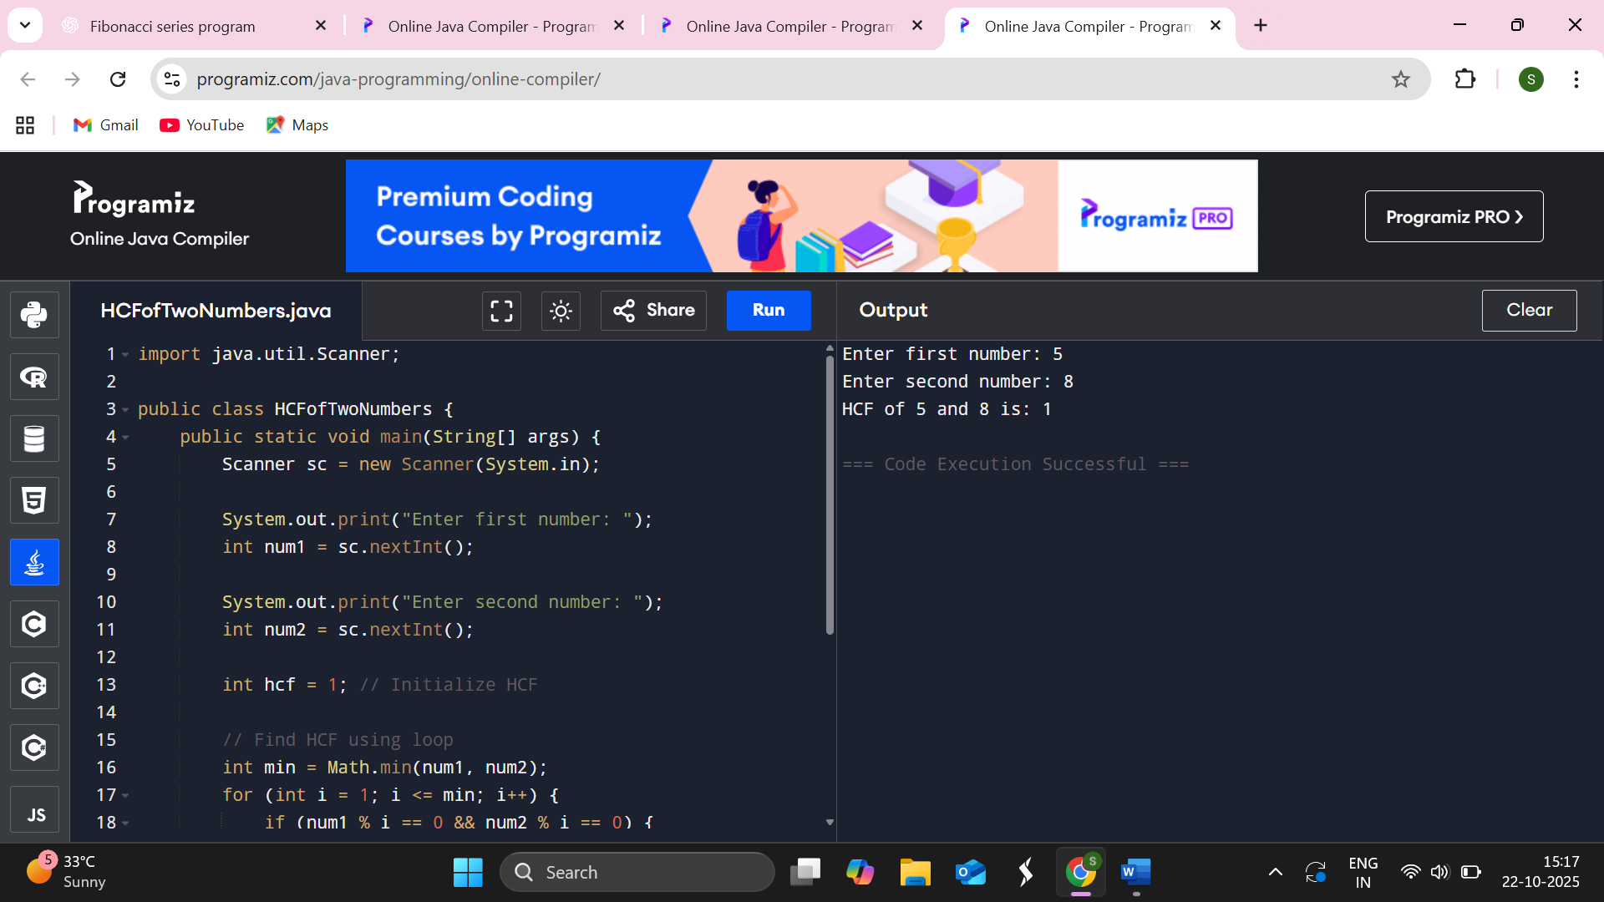

5.Write a program that will display the sum of 1+1/2+1/3….1/n.
Souce code
import java.util.Scanner;
public class HarmonicSeries {
public static void main(String[] args) {
Scanner sc = new Scanner(System.in);
System.out.print("Enter the value of n: ");
int n = sc.nextInt();
double sum = 0.0;
for (int i = 1; i <= n; i++) {
sum += 1.0 / i;
}
System.out.println("Sum of series 1 + 1/2 + 1/3 + ... + 1/" + n + " = " + sum);

sc.close();
}
}
Output
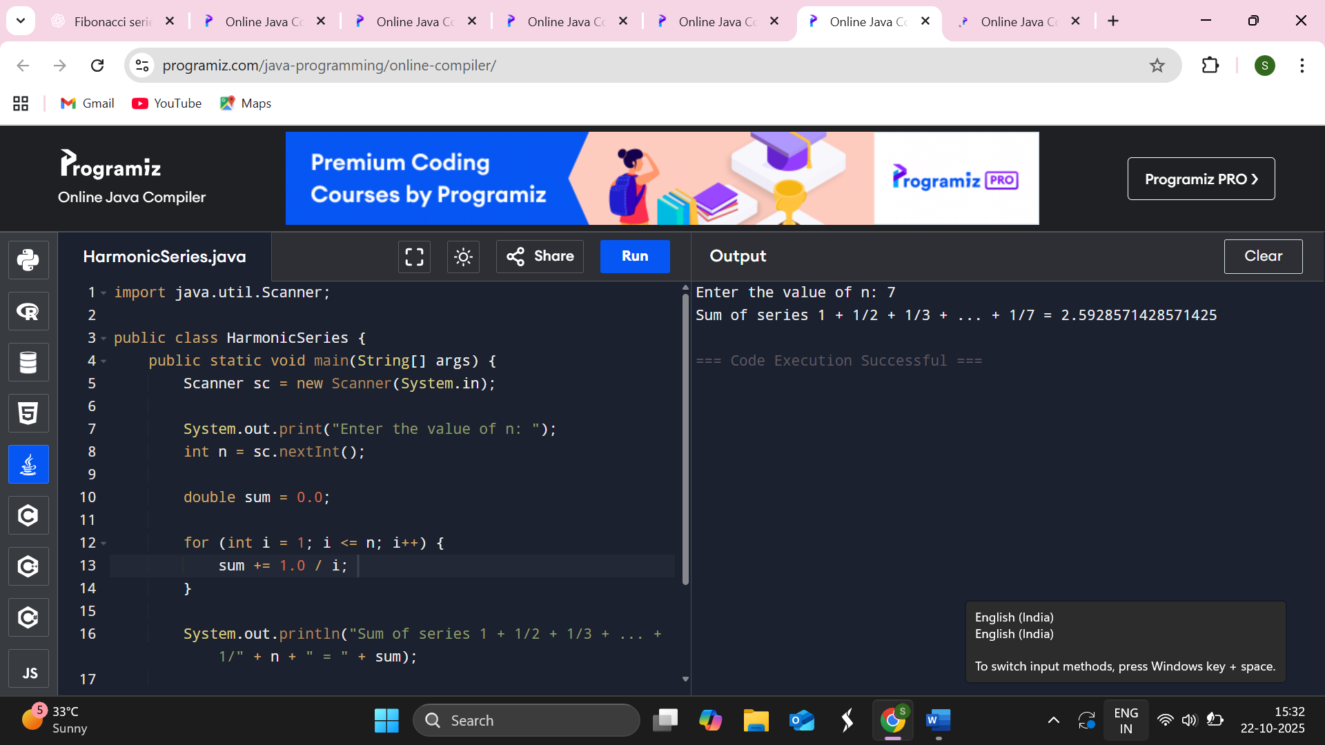

6.Write a program to find product of two matrices.
Souce code
import java.util.Scanner;
public class MatrixMultiplication {
public static void main(String[] args) {
Scanner sc = new Scanner(System.in);
System.out.print("Enter number of rows of first matrix: ");
int rows1 = sc.nextInt();
System.out.print("Enter number of columns of first matrix: ");
int cols1 = sc.nextInt();
System.out.print("Enter number of rows of second matrix: ");
int rows2 = sc.nextInt();
System.out.print("Enter number of columns of second matrix: ");
int cols2 = sc.nextInt();
if (cols1 != rows2) {
System.out.println("Matrix multiplication not possible!");
return;
}
int[][] matrix1 = new int[rows1][cols1];
int[][] matrix2 = new int[rows2][cols2];
int[][] product = new int[rows1][cols2];
System.out.println("Enter elements of first matrix:");
for (int i = 0; i < rows1; i++) {
for (int j = 0; j < cols1; j++) {
matrix1[i][j] = sc.nextInt();
}
}
System.out.println("Enter elements of second matrix:");
for (int i = 0; i < rows2; i++) {
for (int j = 0; j < cols2; j++) {
matrix2[i][j] = sc.nextInt();
}
}
for (int i = 0; i < rows1; i++) {
for (int j = 0; j < cols2; j++) {
for (int k = 0; k < cols1; k++) {
product[i][j] += matrix1[i][k] * matrix2[k][j];
}
}
}
System.out.println("Product of the matrices:");
for (int i = 0; i < rows1; i++) {
for (int j = 0; j < cols2; j++) {
System.out.print(product[i][j] + " ");
}
System.out.println();
}

sc.close();
}
}
Output
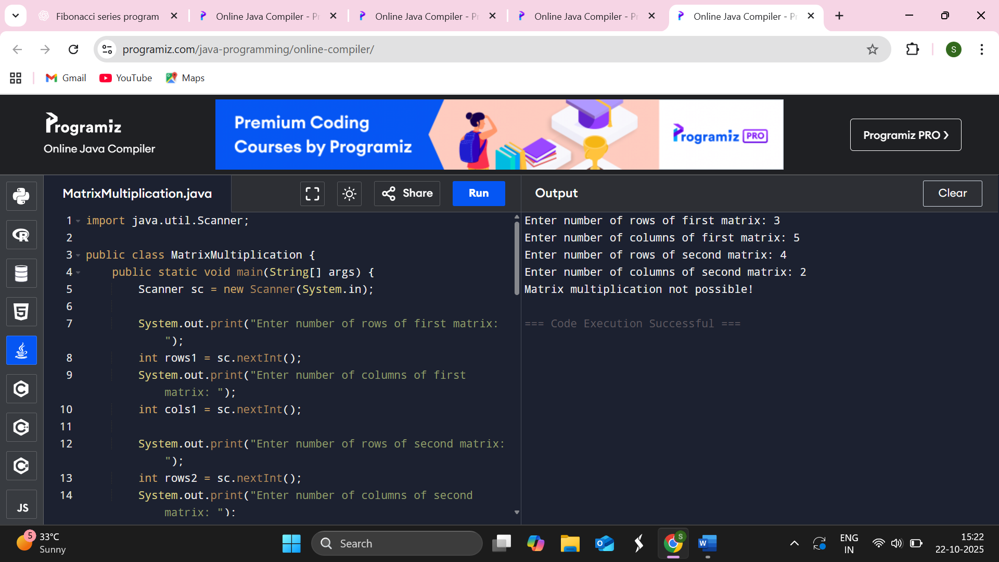
7.Write a Java program to sort the list in ascending order.
Souce code
import java.util.Scanner;
import java.util.Arrays;
public class SortAscending {
public static void main(String[] args) {
Scanner sc = new Scanner(System.in)
System.out.print("Enter the number of elements: ");
int n = sc.nextInt();
int[] arr = new int[n];
System.out.println("Enter " + n + " numbers:");
for (int i = 0; i < n; i++) {
arr[i] = sc.nextInt();
}
Arrays.sort(arr);
System.out.println("Numbers in ascending order:");
for (int num : arr) {
System.out.print(num + " ");
}
sc.close();
}
}
Output

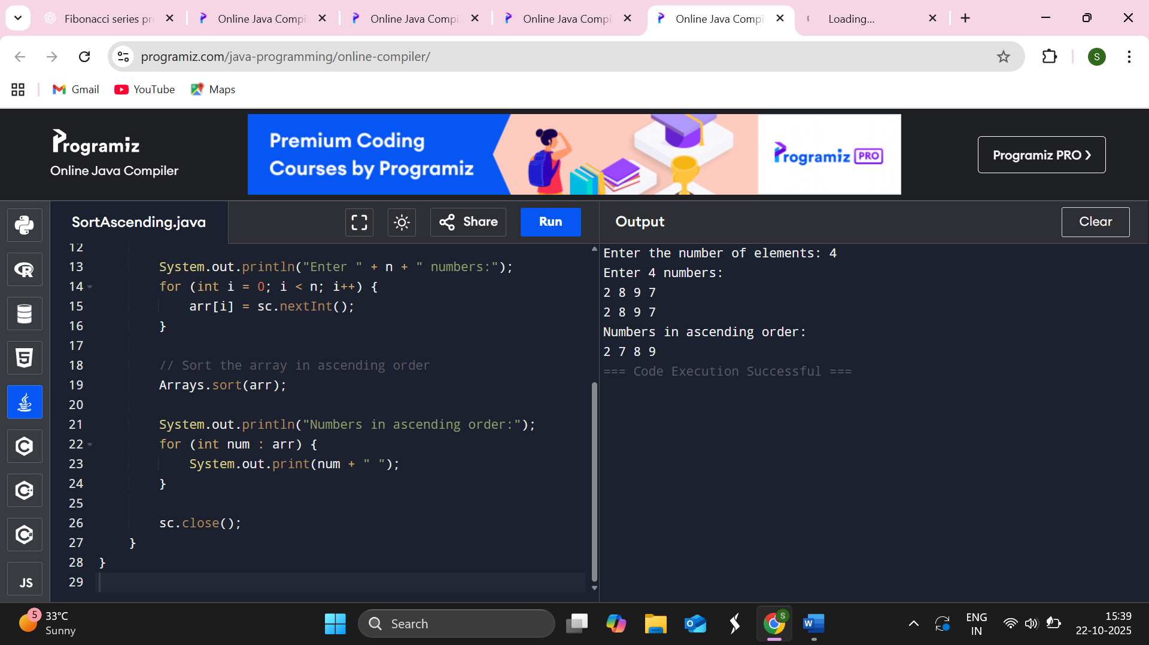

8.Write a java program to find sum and substraction of two matrices.
Souce code
import java.util.Scanner;
public class MatrixOperations {
public static void main(String[] args) {
Scanner sc = new Scanner(System.in);
System.out.print("Enter number of rows: ");
int rows = sc.nextInt();
System.out.print("Enter number of columns: ");
int cols = sc.nextInt();
int[][] A = new int[rows][cols];
int[][] B = new int[rows][cols];
int[][] sum = new int[rows][cols];
int[][] diff = new int[rows][cols];
System.out.println("Enter elements of Matrix A:");
for (int i = 0; i < rows; i++) {
for (int j = 0; j < cols; j++) {
A[i][j] = sc.nextInt();
}
}
System.out.println("Enter elements of Matrix B:");
for (int i = 0; i < rows; i++) {
for (int j = 0; j < cols; j++) {
B[i][j] = sc.nextInt();
}
}
for (int i = 0; i < rows; i++) {
for (int j = 0; j < cols; j++) {
sum[i][j] = A[i][j] + B[i][j];
diff[i][j] = A[i][j] - B[i][j];
}
}
System.out.println("\nSum of Matrices:");
for (int[] row : sum) {
for (int val : row) {
System.out.print(val + " ");
}
System.out.println();
}
System.out.println("\nDifference of Matrices (A - B):");
for (int[] row : diff) {
for (int val : row) {
System.out.print(val + " ");
}
System.out.println();
}
sc.close();
}
}
Output
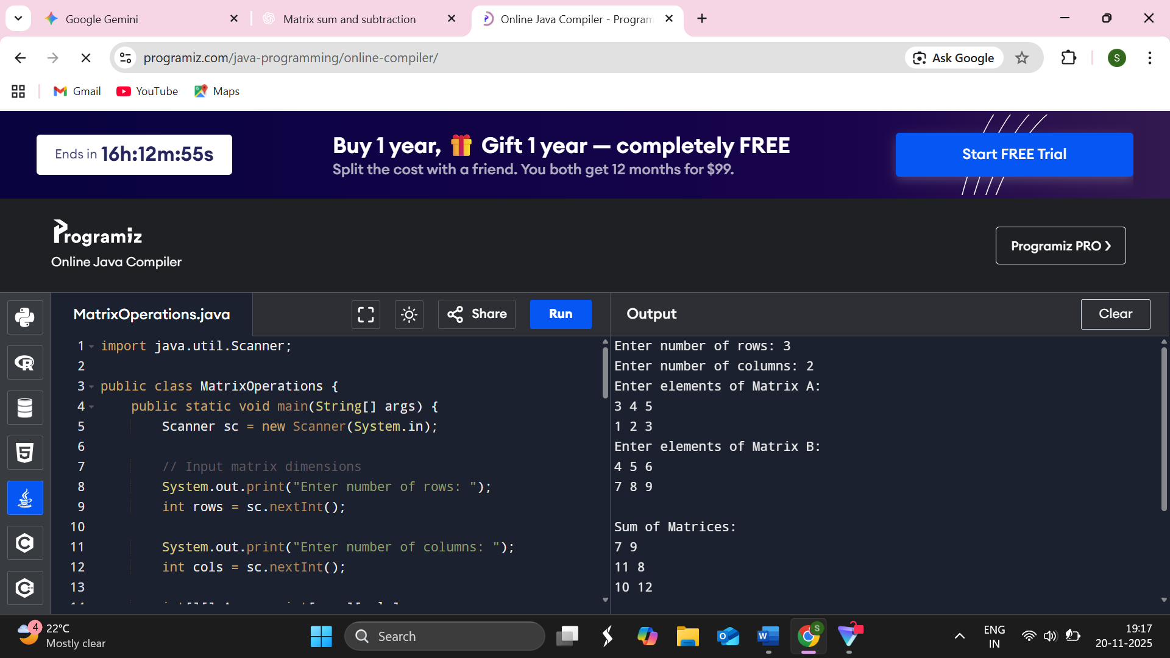
9.Write a java program to convert decimal into binary number.
Souce code
import java.util.Scanner;
public class DecimalToBinary {
public static void main(String[] args) {
Scanner sc = new Scanner(System.in);
System.out.print("Enter a decimal number: ");
int decimal = sc.nextInt();
String binary = Integer.toBinaryString(decimal)
System.out.println("Binary equivalent of " + decimal + " is: " + binary);
sc.close();
}
}
Output
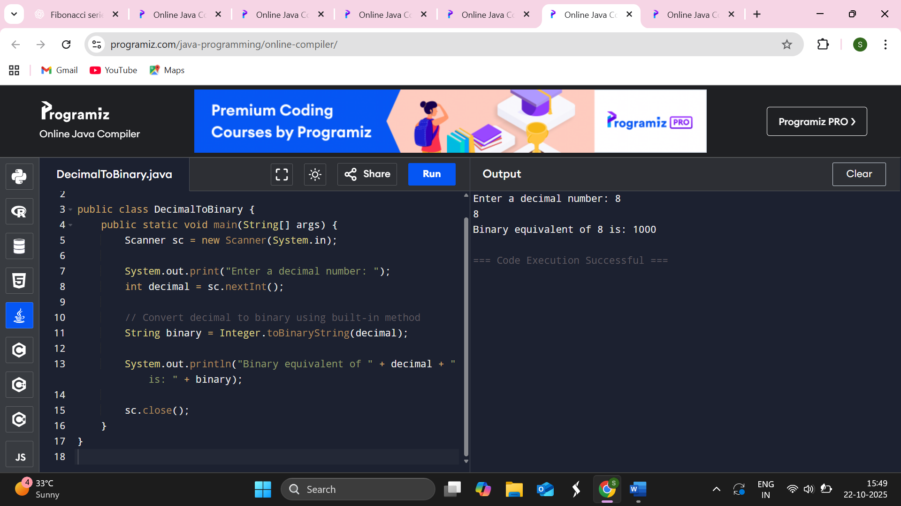
10.Write a java program to find the largest and smallest of n numbers.
Souce code
import java.util.Scanner;
public class LargestAndSmallest {
public static void main(String[] args) {
Scanner sc = new Scanner(System.in);
System.out.print("Enter the number of elements: ");
int n = sc.nextInt();
int[] numbers = new int[n];
System.out.println("Enter " + n + " numbers:");
for (int i = 0; i < n; i++) {
numbers[i] = sc.nextInt();
}
int largest = numbers[0];
int smallest = numbers[0];

for (int i = 1; i < n; i++) {
if (numbers[i] > largest) {
largest = numbers[i];
}
if (numbers[i] < smallest) {
smallest = numbers[i];
}
}
System.out.println("Largest number = " + largest);
System.out.println("Smallest number = " + smallest);
sc.close();
}
}
Output

